Q11. Explain String class **length()** method in java programming?

Ans: Returns the number of characters in the String including space

Syntax:

public int length();

Example:

String x=”Wel come”;

int b=x.length();

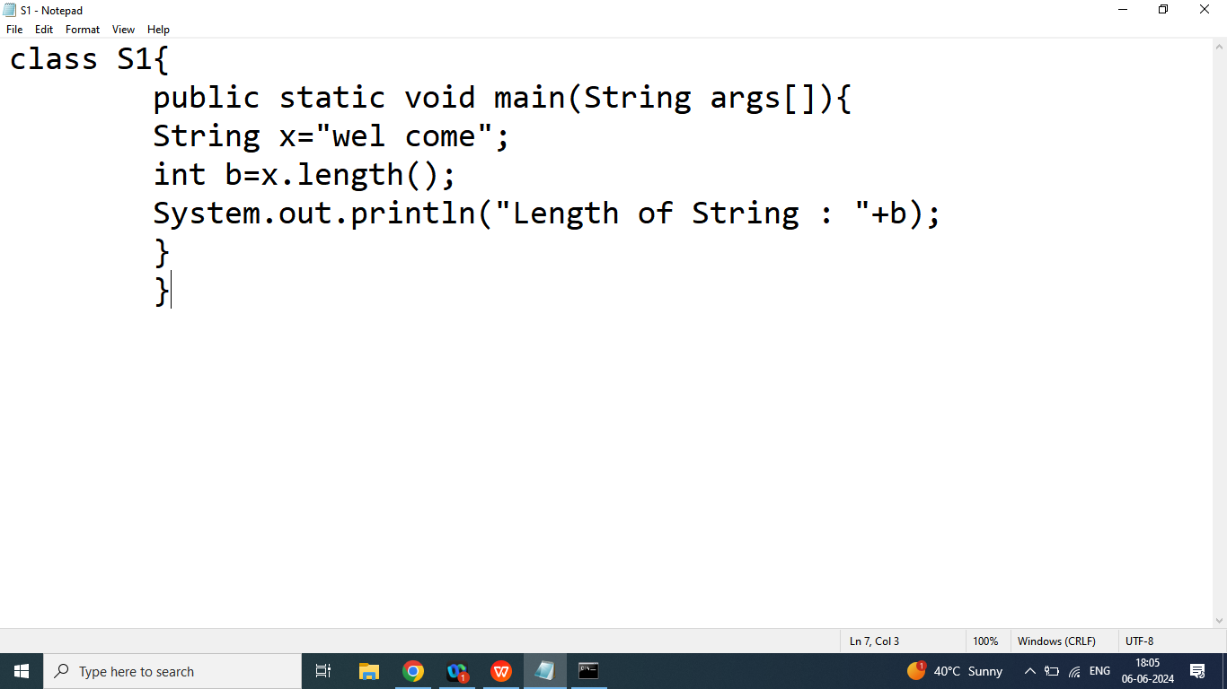

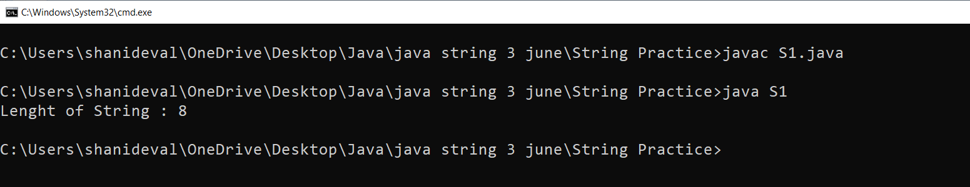

Q12. Explain String class **split()** method in java programming?

Ans: Split a String into an Array of substring

Syntax:

String[] split(separator)

Example:

String sentence=”welcome to bhopal this is city of lake”;

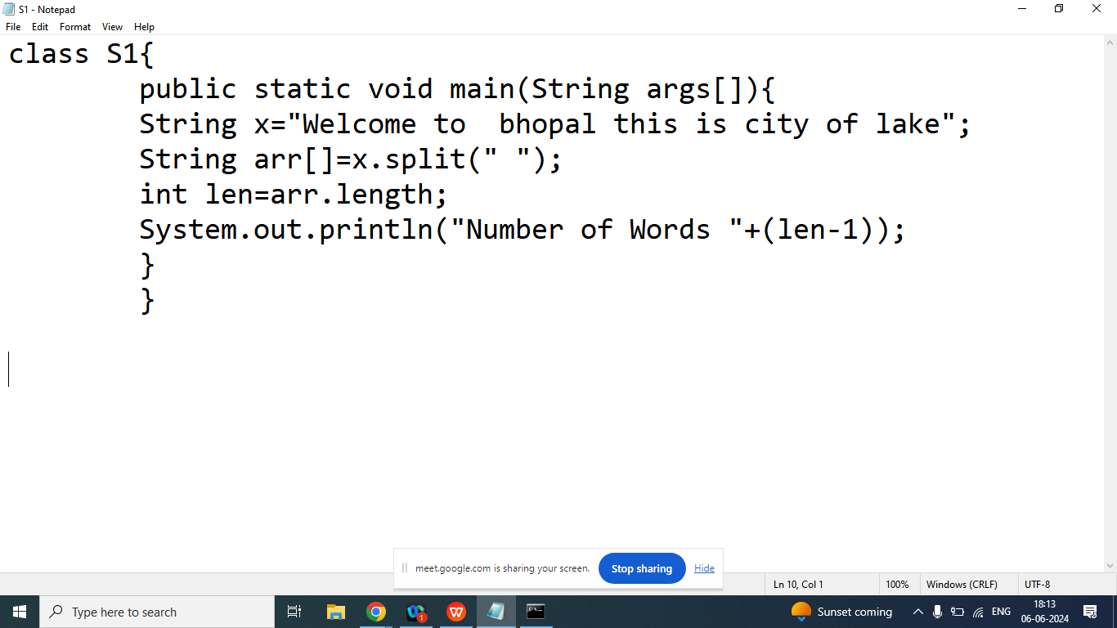

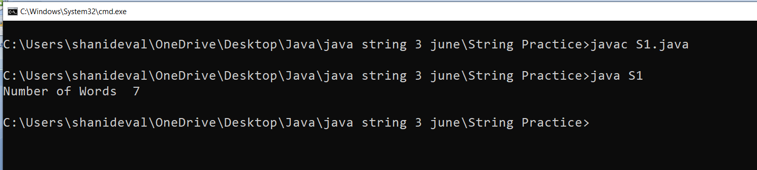

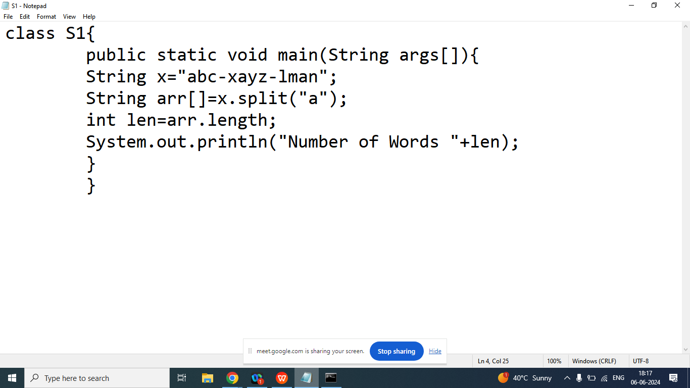

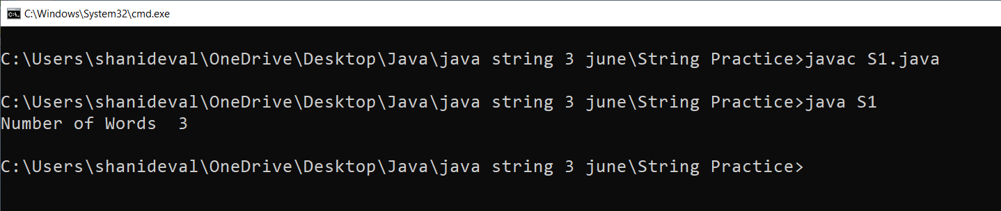

Q14.Explain String class **substring** method in java programming?

Ans: Returns a new String which is substring of a specified String.

Syntax:

public String substring(int start);

public String substring(int start,int end);

Example:

|  |  |  |  |  |  |  |
| --- | --- | --- | --- | --- | --- | --- |
| w | e | l | c | o | m | e |
| 0 | 1 | 2 | 3 | 4 | 5 | 6 |

String x=”welcome”;

String b=x.substring(3); //come

String z=x.substring(0,4);//welc

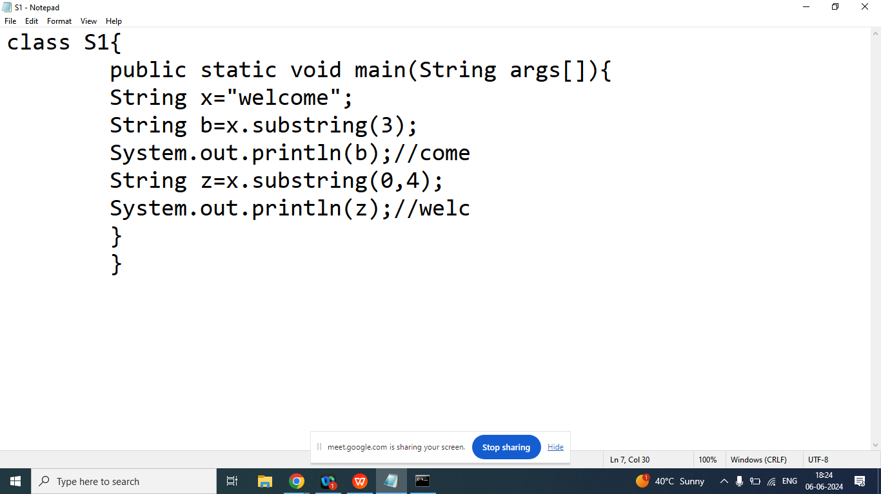

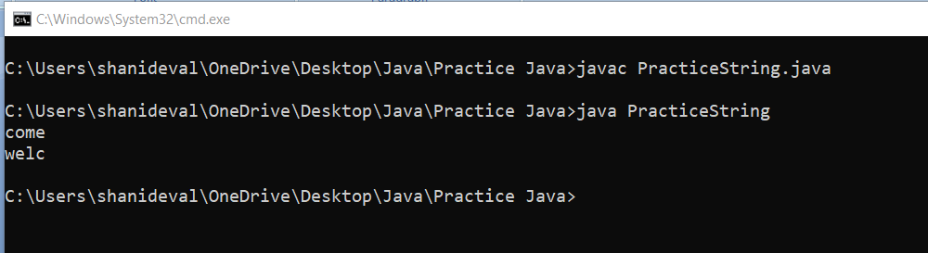

Q6. Explain String **class toCharArrray(**) method in java programming?

Ans: It is used to convert given String into char array

Syntax:

public char[] toCharArray()

Example:

String x=”welcome”;

char arr[]=x.toCharArray();

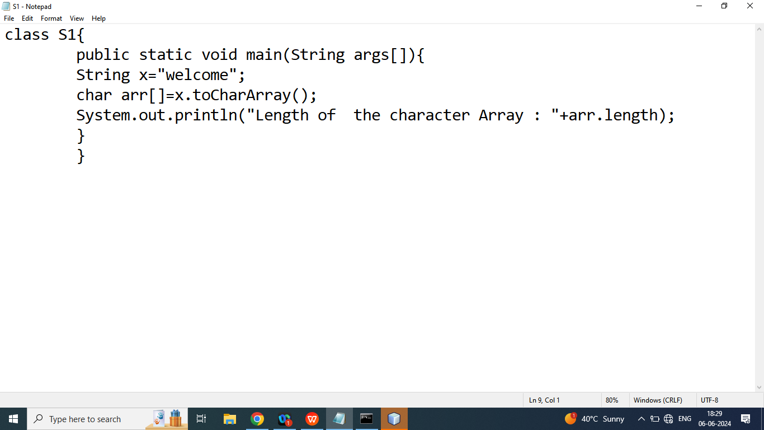

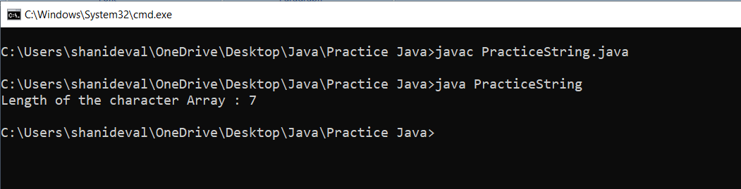

Q7. Explain String class **toUpperCase** and **toLowerCase()** method in java programming?

Ans:

toUpperCase(): It is used to convert upperCase String

toLowerCase(): It is used to convert upperCase String

Syntax:

String x=”welcome”;

String a=x.toUpperCase();

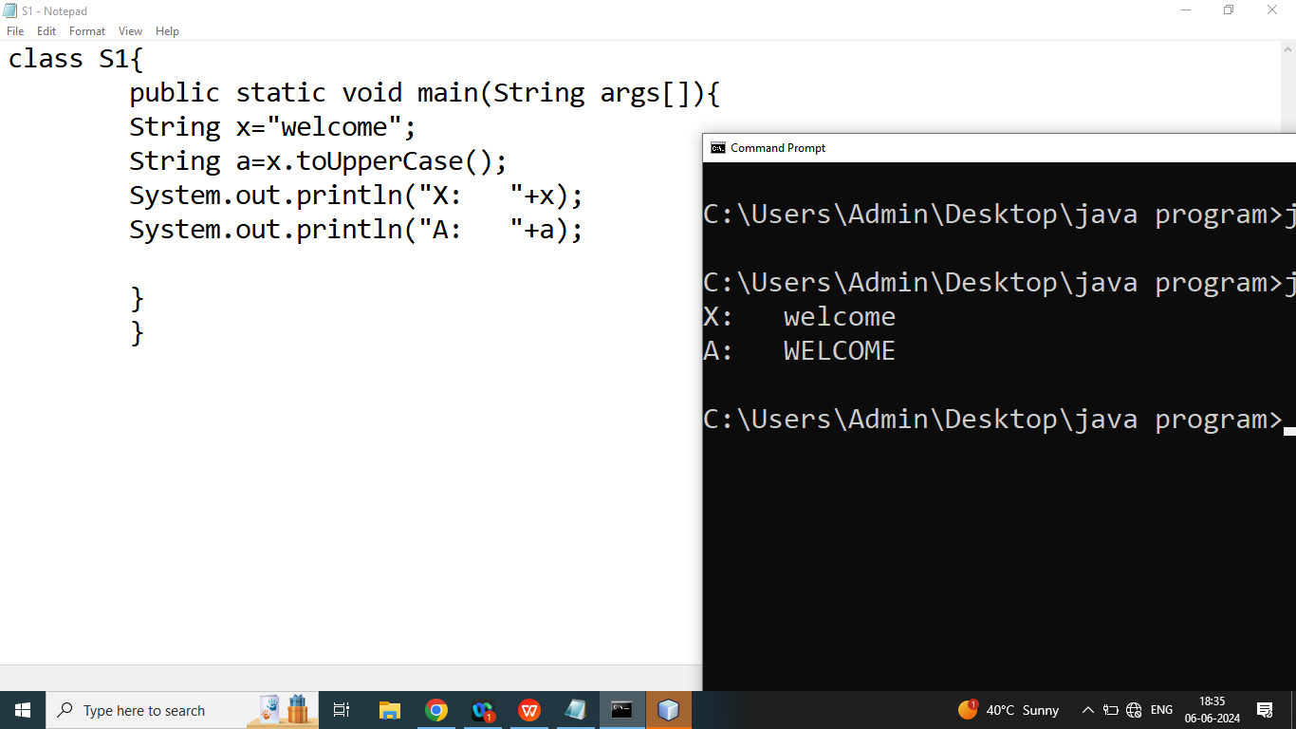

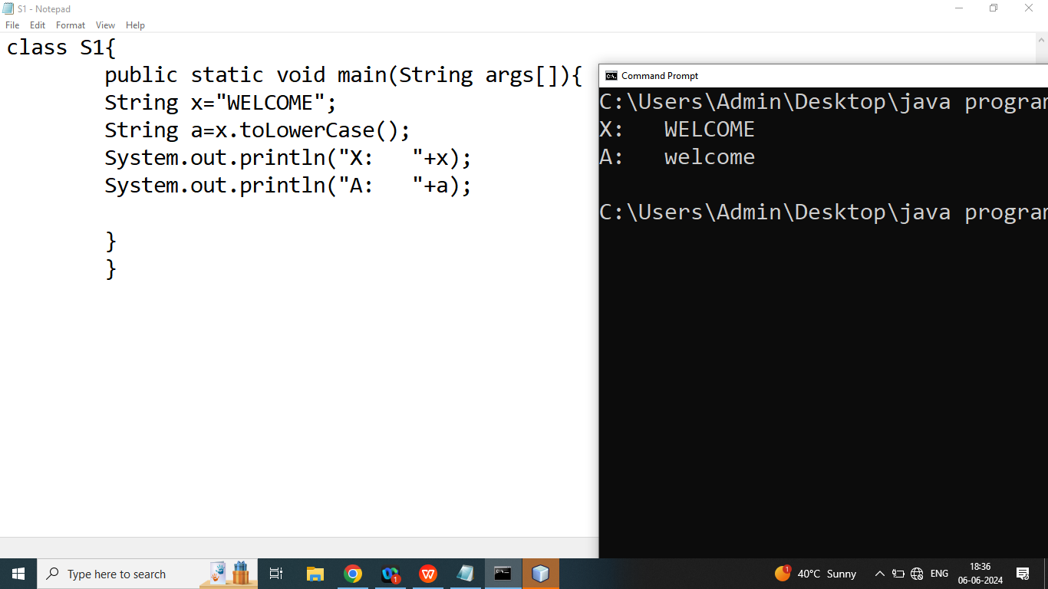

Q1. Explain String class **trim()** mthod in java programming?

Ans: Removes white spaces from both ends(starting and ending)

Syntax:

String trim();

Example:

String str=” Hello World ”;

String a=str.trim();//Hello World

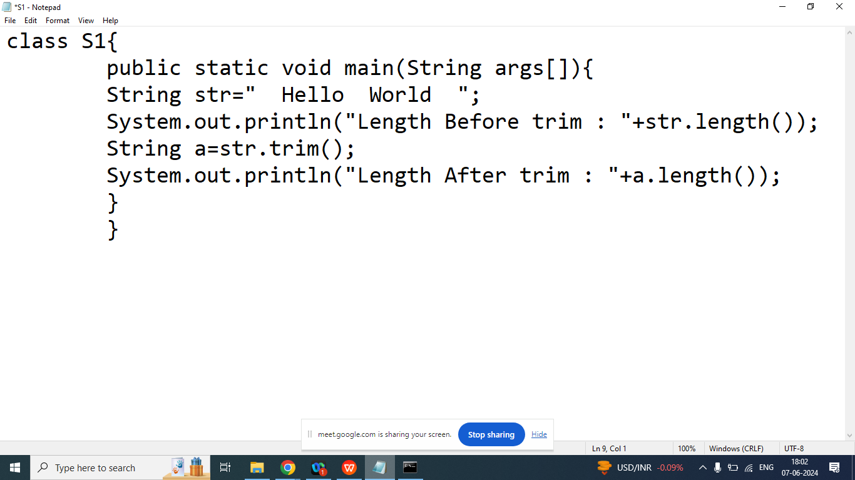

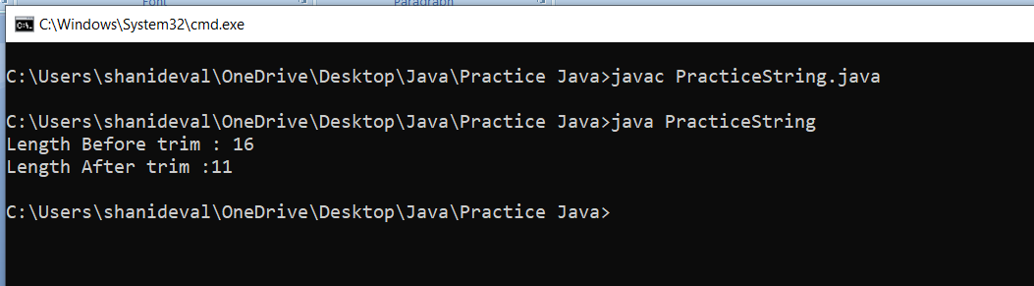

Q2. Explain String class **valueOf()** method in java programming?

Ans: Returns the String representation of the specified value

Syntax:

String valueOf(Integer)

String valueOf(Float)

String valueOf(double)

String valueOf(Char)

String valueOf(boolean)

Example:

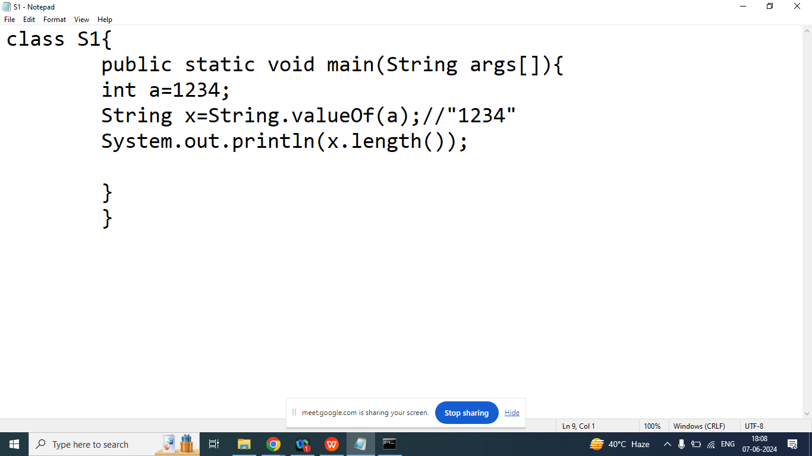

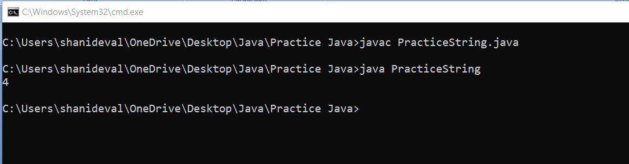

Q1. How many Object created in below program

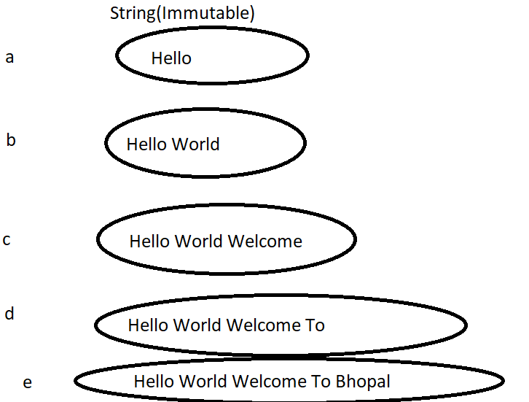

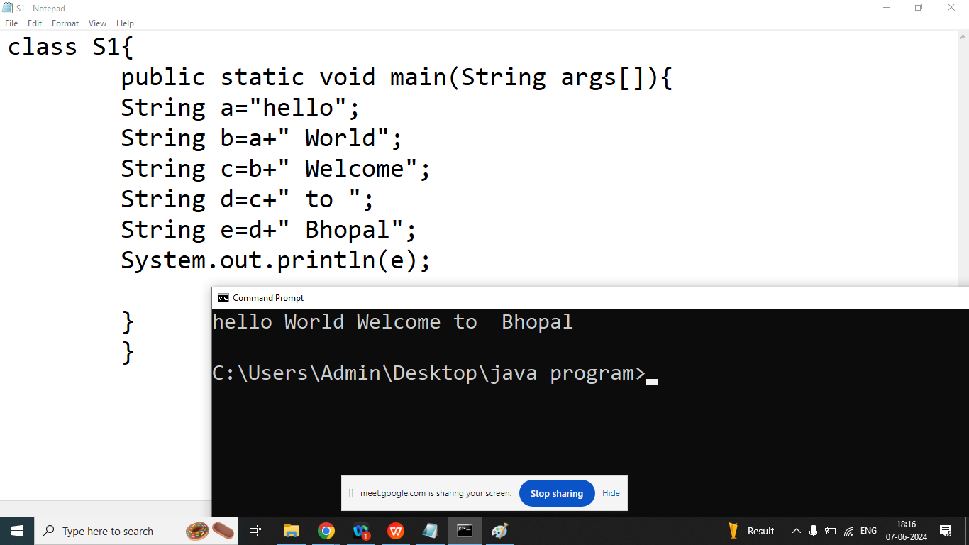

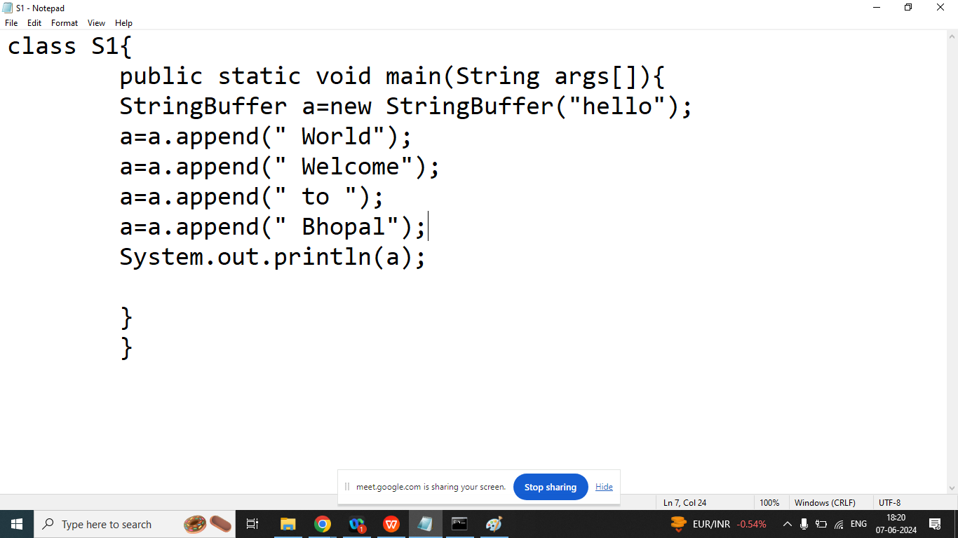

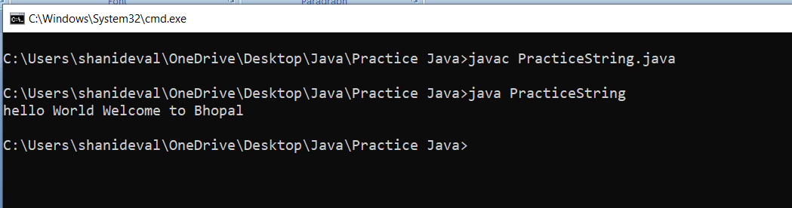

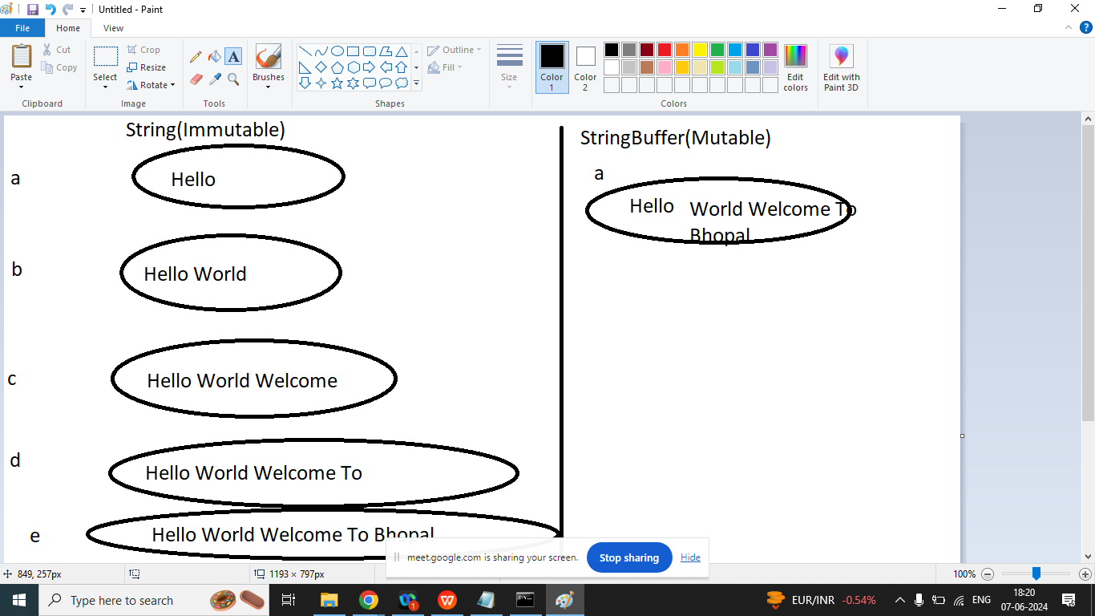

Q1.Explain StringBuffer class in java Programming?

Ans:

If our content are not fixed and we want to perform some modification but thread safety is required then we should go for StringBuffer class.

String Buffer class is a Mutable class present in java.lang package

Constructor of StringBuffer class

1. StringBuffer(): It creates an Empty String Buffer class object and reserves space for 16 character(Default capacity of StringBuffer is 16)
2. StringBuffer(int capacity): It creates an empty StringBuffer object with the specified capacity
3. StringBuffer(String): It creates a StringBuffer object from the specified String. And its capacity=default capacity+ length of the String.

